Clothe Yourself in Love for the Suffering Children of Sudan:
A Book Study

By Judy A. Bernstein and Mat Merker

Prerequisite: All participants should prepare for this session by reading

They Poured Fire on Us from the Sky: The True Story of Three Lost Boys of Sudan

by Benson Deng, Alephonsion Deng, and Benjamin Ajak with Judy A. Bernstein
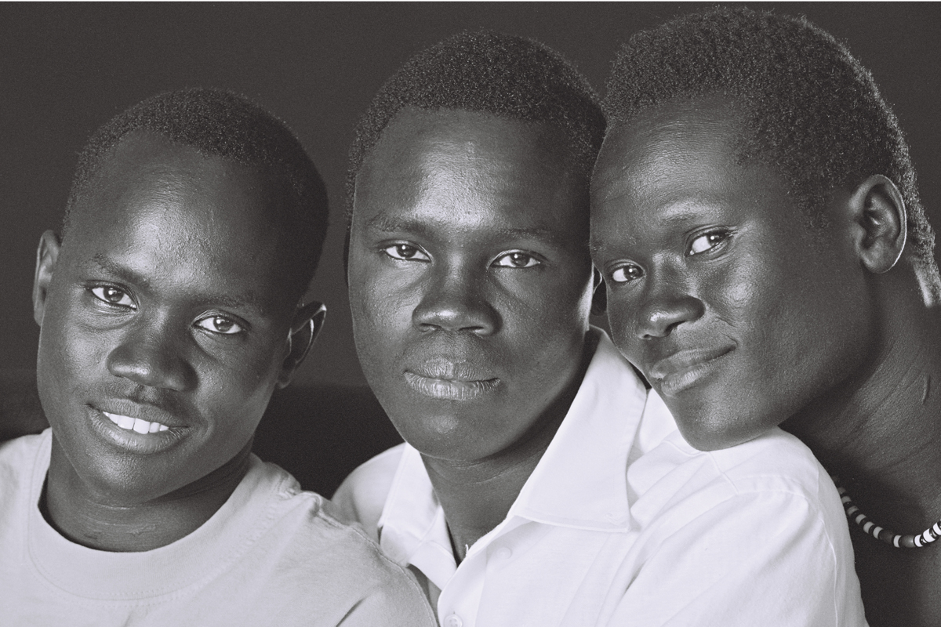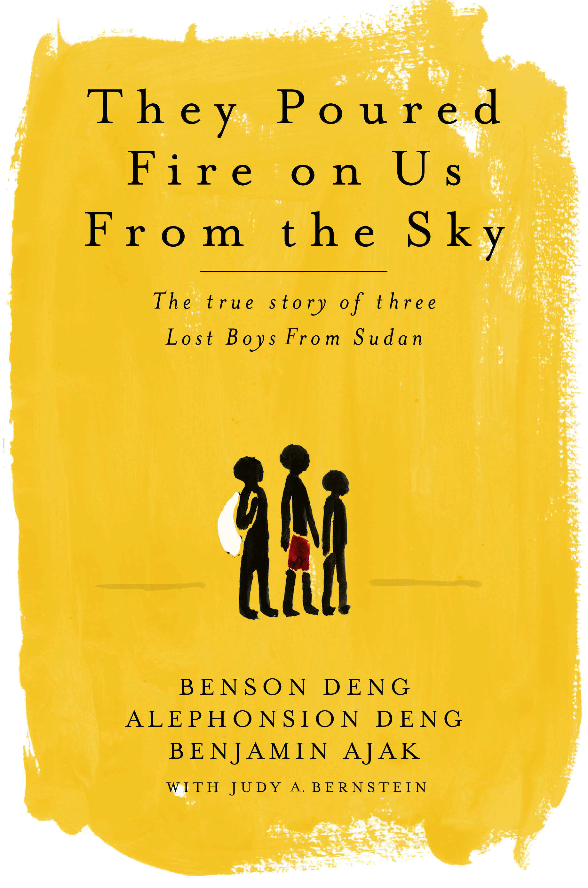
This book is available through Cokesbury at http://www.cokesbury.com/

Focus Image:

On the wall or an easel behind a small table, place a map of Africa. Take a piece of gray paper the shape of Sudan and place it on the map over the country of Sudan. Cover the table with brown paper or a brown or gray cloth. Place a cross on the table. The cross should be pristine and shiny. In front of the cross place a torn dirty unsliced loaf of bread, a glass jar half filled with dirty water, an obviously dirty T-shirt, and one child’s flip flop. A dusting of cocoa powder makes a good substitute for dirt on the bread and a small amount will cloud the water. The observer should be able to easily see that a fleeing refugee child would treasure these dirty, worn items.

Focus Statement:

The purpose of this program is to inspire individuals to reflect upon the suffering of the children caught up in the genocide of war-torn Sudan. We hope that reading They Poured Fire on Us From the Sky and discussing the selected problems presented will challenge you to think and empower you to action.

Scriptural Focus: Psalm 102: 3-8, 18-27

Directions for the Leader:

Divide the group into smaller groups of no more than four to eight people in a group. Provide pencils and index cards (two 3 x 5 cards) for each participant. Be sure at least one copy of They Poured Fire on Us From the Sky is in each group. Begin with the opening prayer.

Opening Prayer

Leader: We come together today, Lord, beginning to understand the suffering of the people of Sudan, especially the homeless, terrified children struggling to survive – not day-to-day, but minute-to-minute – in their country wracked by barbaric, genocidal civil war. Open our eyes, our ears, and our hearts, Lord, for our culture of plenty has distanced and insulated us from truly experiencing the suffering of others.

We count carbs and calories, wondering what to eat today.
They wonder if they will eat today.

We look at a closet full of clothes and complain we have nothing to wear.
They dress in the ragged remnants of what they were wearing the night their village exploded.

We sit in an air-conditioned car stalled in traffic, frustrated and annoyed that our commute is prolonged.
They trudge barefoot down a hot, dusty road to an unknown destination and a questionable future.

Lord, waken our hearts and minds. Stir our souls, that we may become your hands acting in ways to benefit these children and promote peace in the Sudan. We ask this in the name of your precious Son. Amen

Centering Our Focus: To help participants identify with the experiences of the Lost Boys, we invite you to share an imaginary experience together.

1. An Imaginary Trip

Leader: I would like to take you on an imaginary trip. Please sit comfortably with your feet flat on the floor and your hands resting gently in your lap. Close your eyes. Listen to your body. If you sense tension or discomfort in your body, adjust your position to become more comfortable. When you are comfortable, slowly bow your head.(When all heads are bowed, begin to read the following script. African music can play softly in the background.)

You are seven years old.
When school starts this fall, you will be in third grade.
It has been a busy summer day. But now the sun is turning the clouds brilliant gold and shades of mauve as it sets.
It is bedtime. Your teeth are clean. Your skin smells like your favorite soap. Your bare feet slap on the floor.
Walk into your bedroom. Look around the room. What do you see? What colors? What objects? (Pause. Silently count to ten: one-one thousand, two-one thousand, etc., allowing time for the listeners to visualize their childhood bedroom)
Climb into bed. Feel the cool sheets against your warm skin. Is someone tucking you in?
Who is it? (Brief pause)
What do they say? What do they do? (Pause for a 10 count)
The light in the room darkens. Your breathing becomes deeper, slower. You drift into dream-free sleep. (Pause for a 15 count)

Abruptly you are jerked awake. (Louder, harsher voice)
Wake up! Wake up! Get out of bed.
Shhh! Don’t make a sound.
You can hear popping like a dozen firecrackers.
You can see bright fireworks in the sky like 4th of July. Boom! Boom!
But it isn’t the 4th of July. Those aren’t cap pistols or fireworks.
“Go with your brother!” someone says. Run! Run away! Run now!
Terror floods you. Your hands shake. Your pulse pounds.
Smoke and flames are all around. The popping sound is coming toward you.
Run! Keep running!
Breathing is hard. There is a stitch in your side. Your bare feet pound the ground. Run! Keep running! (Pause for a 5 count)
You can run no farther.
Sink to the ground hidden beside a bush. Look back. What do you see? (Pause for a 5 count)
What are you feeling? What will you do? (Pause for a 20 count)

We are fortunate. For us, this scenario is just a bad dream. When we open our eyes, we will be in a safe, familiar place surrounded by friends. But this was reality for Benson, Benjamin, and Alepho (pronounced Ah – lay – foe). This was what the beginning of the horror was like for them.

Alepho said, “ As a boy of 7, I ran barefoot and naked into the night and joined up with streams of other boys trying to escape death or slavery. We crossed thousands of miles of war-ravaged country without hope of sanctuary. Bullets replaced food, medicine, shelter and my loving parents. I lived on wild vegetables, ate mud from Mother Earth, and drank urine from my own body. We walked five years…”

Slowly riase your head, open your eyes, gaze at your friends, and take a deep breath.
One by one, share with each other what this experience was like for you. What did you see? What did you hear? How did you feel? Describe your emotions as you participated in this visualization. What thoughts raced through your head? (Monitor the crowd and as the buzz begins to die down, move on to the next exercise.)

2. A Reading

Leader: Instruct the group to turn to page 57 in They Poured Fire on Us From the Sky and read aloud pages 57–60, ending with the sentence “Men had done too many evil deeds and they had darkened the day.”

Leader: After the reading, ask the groups to write down on the index cards one or two words that describe their reaction to this reading. Begin the small group experience by sharing these words and asking individuals to explain their reason for choosing them. Then begin to discuss the following questions.

Questions:
.
- What does the African proverb at the beginning of the book “When two elephants fight, it is the grass that gets trampled,” mean to you?

- These boys lost their homes and families, were thrust into terrible suffering, and saw things we as adults have never seen. What do you think made them want to keep going when at times it would be so easy to sit under a tree and leave all that pain?

- Was your lasting impression of They Poured Fire on Us From the Sky one of hope, or one of despair? Will anything change in the world?

- How can we as Christians ease the suffering of children and families like these? Please write down your top three suggestions and mail them to:

The Sudan Action Team
Holston Conference, The United Methodist Church
P.O. Box 32939
Knoxville, TN 37930-2939

Closing Prayer.

Your Son, O heavenly Father, brought a message of love and peace to the world. He drew the children to His side and cautioned us all to care for them, to protect and nurture them. The children of the Sudan continue to suffer each day. May their daily anguish drive us to respond in ways that will comfort and console, that we may fulfill Christ’s direction. Help us to become elephant tamers that the grass may grow – to become those who move to bring peace to the world. Amen

Recommended Reading:

Scroggins, Deborah. Emma’s War. An aid worker, a warlord, radical Islam, and the politics of oil – A true story of love and death in Sudan. Pantheon Books. 2002.

Nazer, Mende and Lewis, Damien. Slave: My True Story. Public Affairs. 2003.

Deng, Francis Mading. The Dinka of Sudan. Waveland Press, Inc. 1972.

Bok, Francis with Edward Tivnan. Escape from Slavery. St. Martin’s Press. 2003.

Jok, Madut Jok. War and Slavery in Sudan. University of Pennsylvania Press. 2001.

Related Websites:

www.SudanHope.Holston.org Holston Sudan Action Team

www.TheyPouredFire.com Book: They Poured Fire on Us From the Sky

www.PassionofthePresent.org Sudan: Passion of the Present

www.GenocideInterventionFund.org Genocide Intervention Fund

www.SaveDarfur.org Save Darfur
www.TheIRC.org The International Rescue Committee

www.CrisisGroup.org International Crisis Group

www.hrw.org Human Rights Watch

Deng, A (_October 31, 2005) I have had to learn to live with peace, Newsweek

